**Branches in Git**

* Git allows us to work parallelly for different use cases
  + multiple versions of same application
  + multiple customers for same application  
    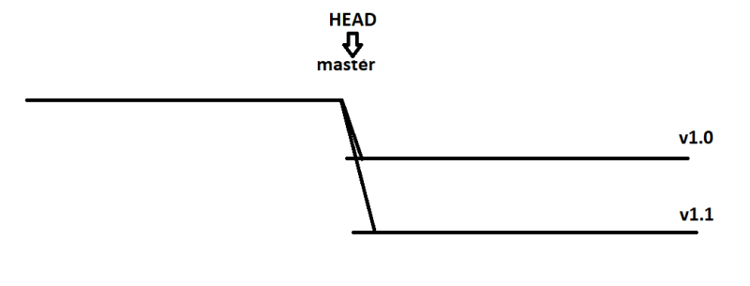
* HEAD is a pointer which generally points to a branch
* HEAD can be moved from one branch to other using a command called as **checkout**
  + We executed git checkout v1.0  
    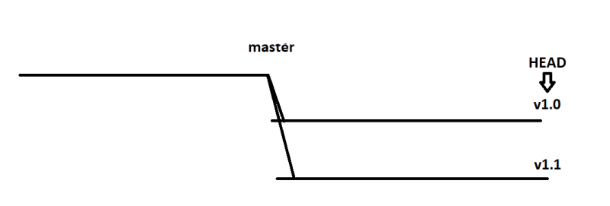
* to work with branches lets use nopcommerce <https://github.com/nopSolutions/nopCommerce/branches>   
  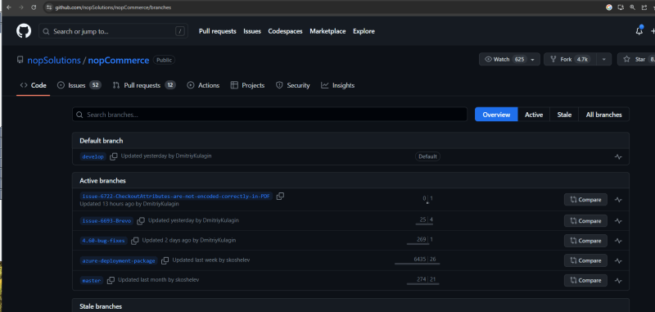
* Moving from one branch to other  
  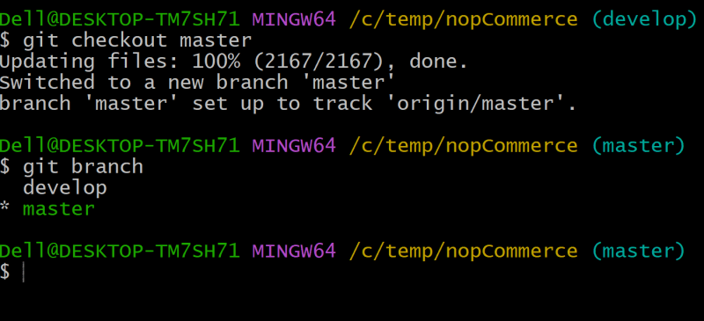
* Things to digest
  + default branch: master
  + default remote: origin
  + remote branch: name of remote/name of branch

**Building and packaging the code**

* Building the code and packaging the code to the suitable format for end deployment is very technology specific i.e. it is different depending on programming languages.
* Programming Languages can be categorized into 3 formats

Compiler based  
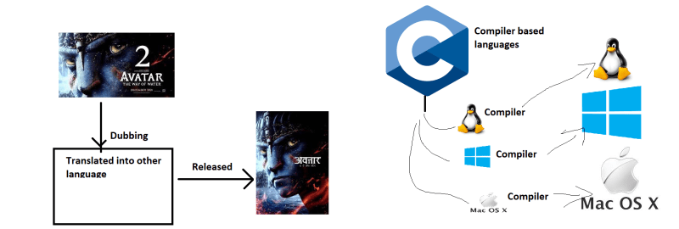

Interpreter based

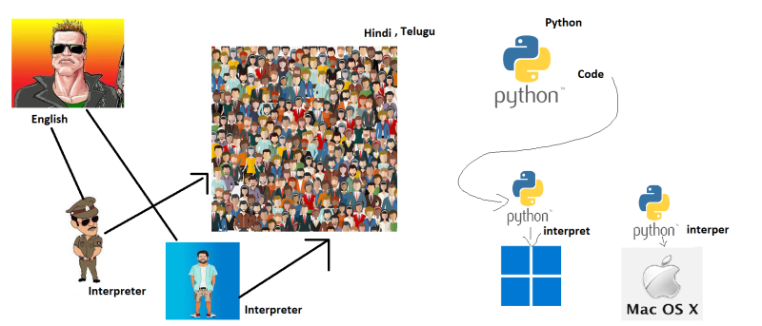

Hybrid Based  
